Gutter website

Home page

Main image

FREE INSPECTION & QUOTE PARTOUT

**About us**

Small paragraph to present the company

Melbourne based company we provide services in all Victoria

**Services**

Gutter cleaning

Gutter mesh protection installation

Vermines, oiseaux, leaves,

Products

Aluminium mesh top quality

Plastic mesh

We work on

Tiles

Corrogated

Flat roofs (trim deck)

Box gutter

Repointing

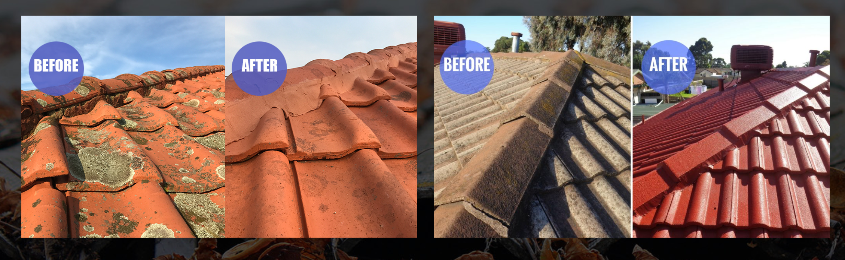

Roof cleaning

Roof painting

Re-bedding & Capping

Solar panel cleaning

Trim Installation and screws

Silicon on the corners

10 years + experience in roofing

6 years + gutter protection

Roof renovation